**Company Organization Structure Functionality Over OP2**

**Home Menu > Company Settings > Global Standards > Company Organization Structure**

**Features:** In Company organization Structure have a hierarchal structure where the objects are created over it, Structure Like (Zone, Sub Zone, Market, Company, Facility etc.)

In COS, we here to describe the functionality of Cut or Copy the facility node from other Zone and paste facility other under any Zone.

When we create the object under the facility which were paste under that particular Zone and see the object is create over its facility or not.

**Functionality:**

**Home Menu > Company Settings > Global Standards > Company Organization Structure**

First, we go to Home Menu Company settings (Configuration).

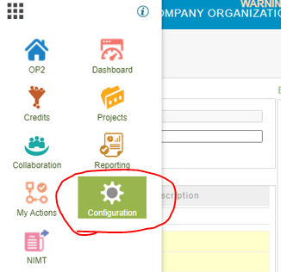

Select Company Organization Structure under Global Standards.

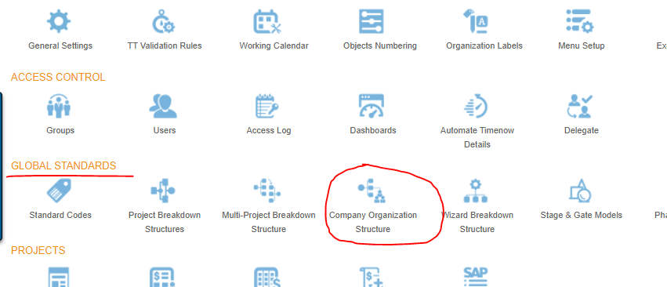

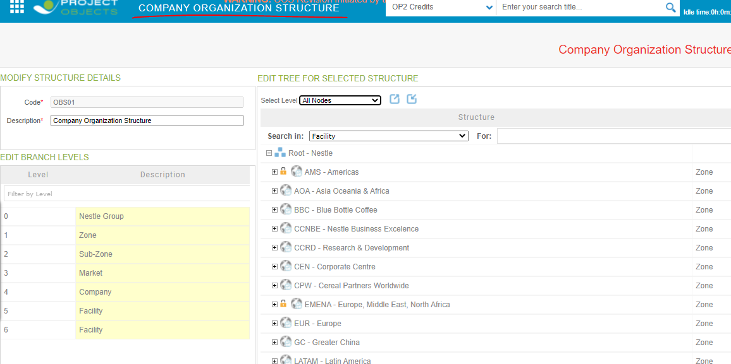

Now we select the Zone NQAC and select the facility 0433- US SL NQAC Dublin of this parent node then select Cut on right button click.

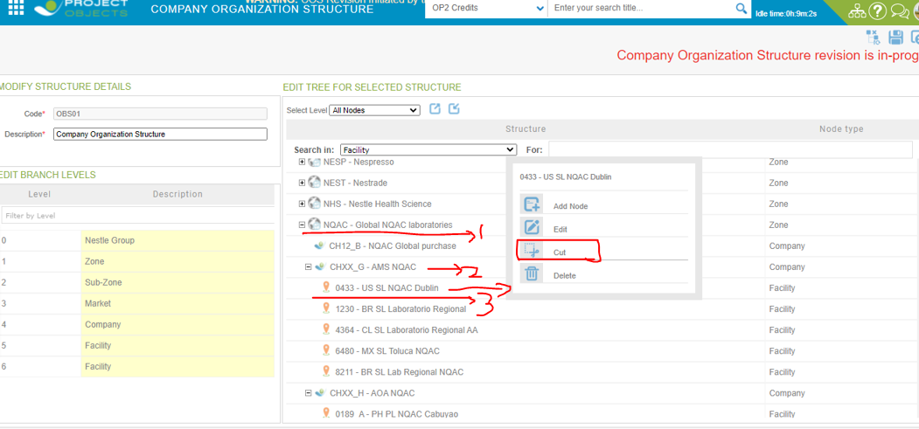

When you select Cut then it will be visible like below screenshot.

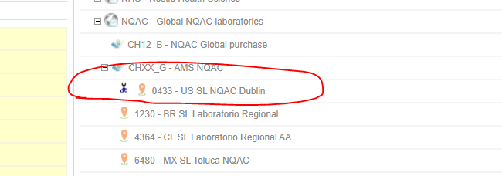

Then after we want to paste under NT Nestle Special T , On right button click we paste the facility which were we cut from NQAC.

So paste facility under CH11_B-Special T

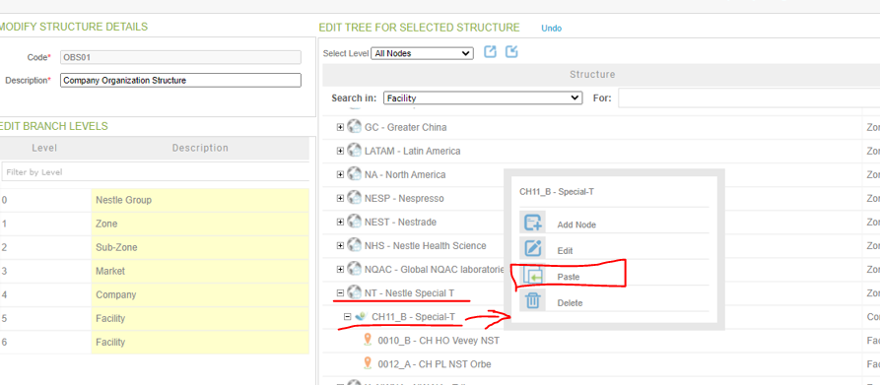

After select paste option, facility node visible under the CH11-B-Special T and then click on save button.

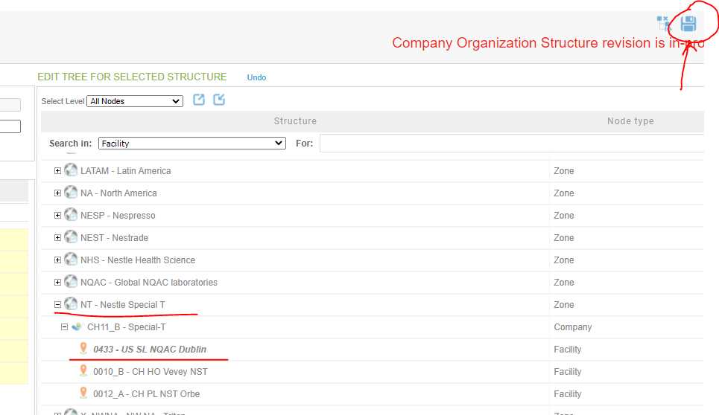

Facility node will be not visible After cut the facility node from NQAC.

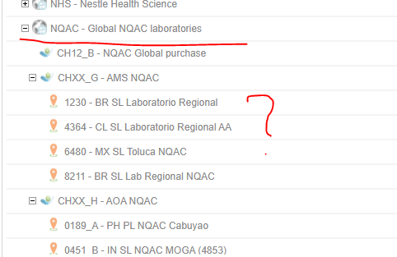

Now we create the object under NT zone and we make sure that object will be create or not on particular node.

For creation Object:

Home Menu > Credit > Credit Submission > Add Icon

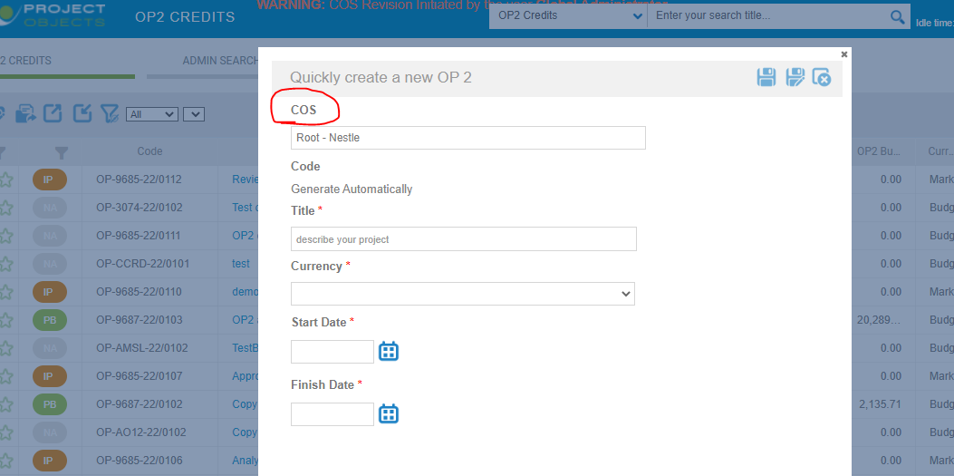

Select COS Facility node under NT-Nestle Special T. Paste facility node is visible under zone NT node.

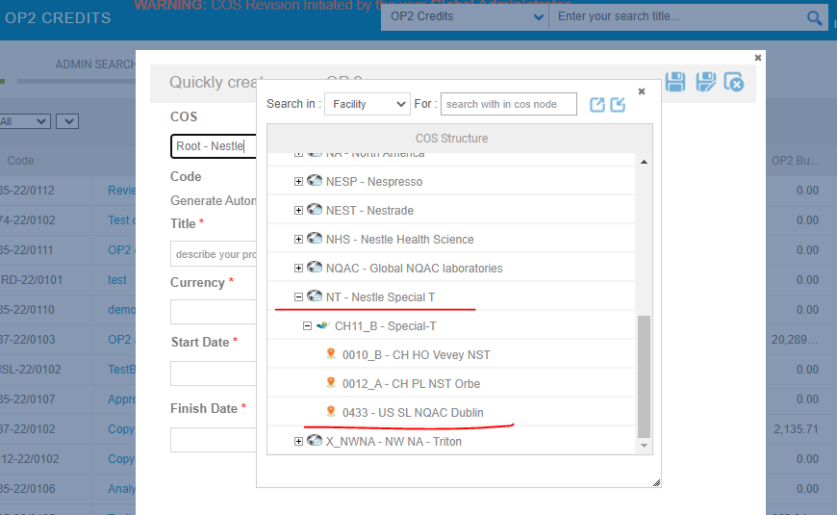

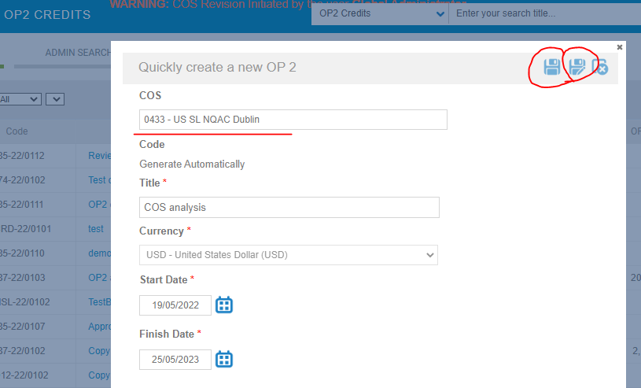

After save object , facility node is visible in Object details page.

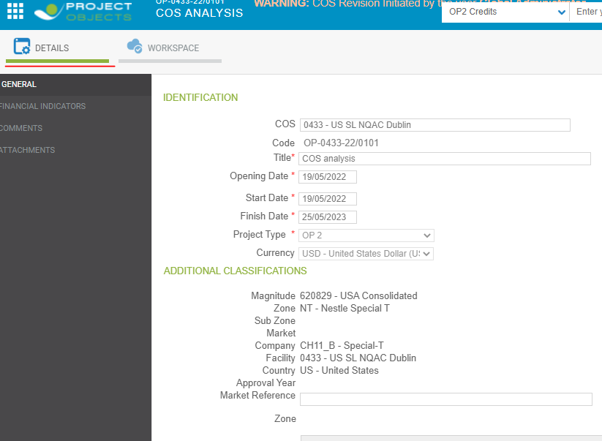

# Other specifications:

If on right button click CUT and DELETE option is not visible then must select the company organization structure revision.

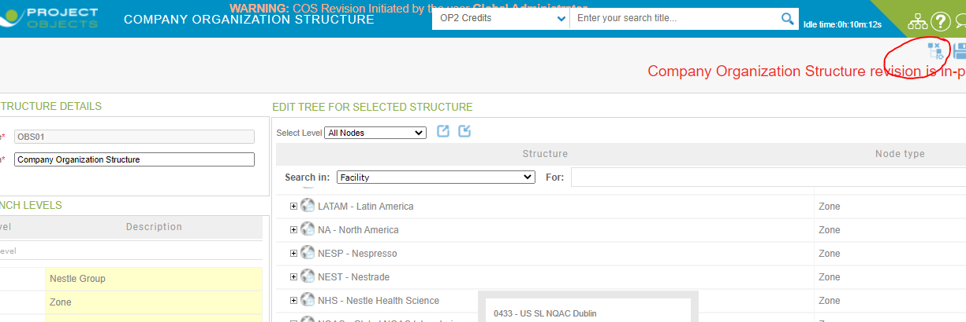

We can delete, edit, add node also in COS and also create the Zone, sub zone, company and facility from Standard codes.

Select COS Master Data in standard codes, we click on **plus** icon for add the items under the node.

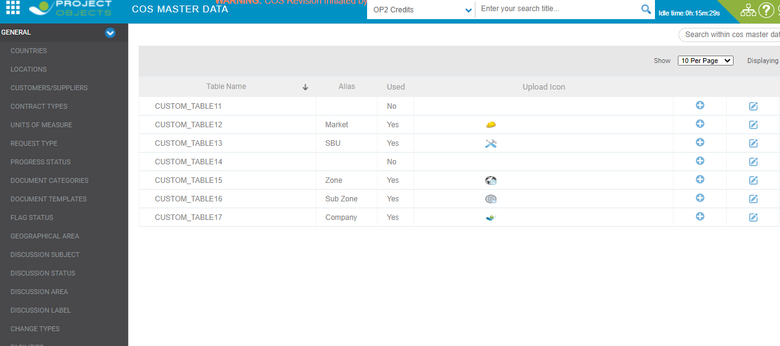

Then list is visible here.

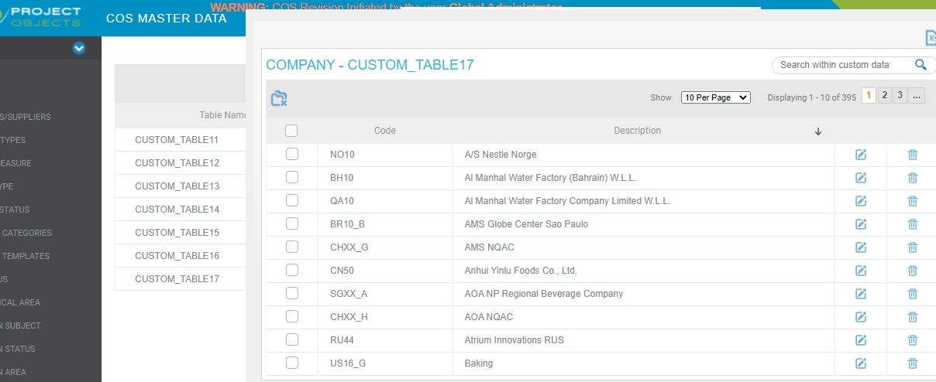

**Thank You………**